* Take the standard nginx image and push it to private registry

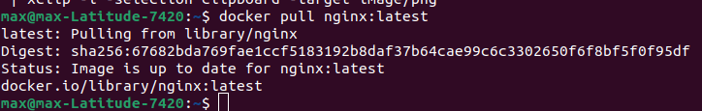

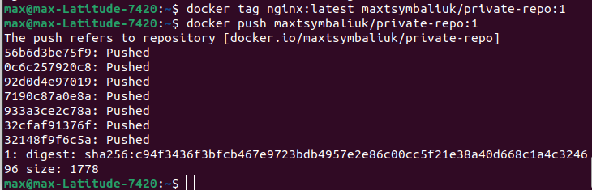

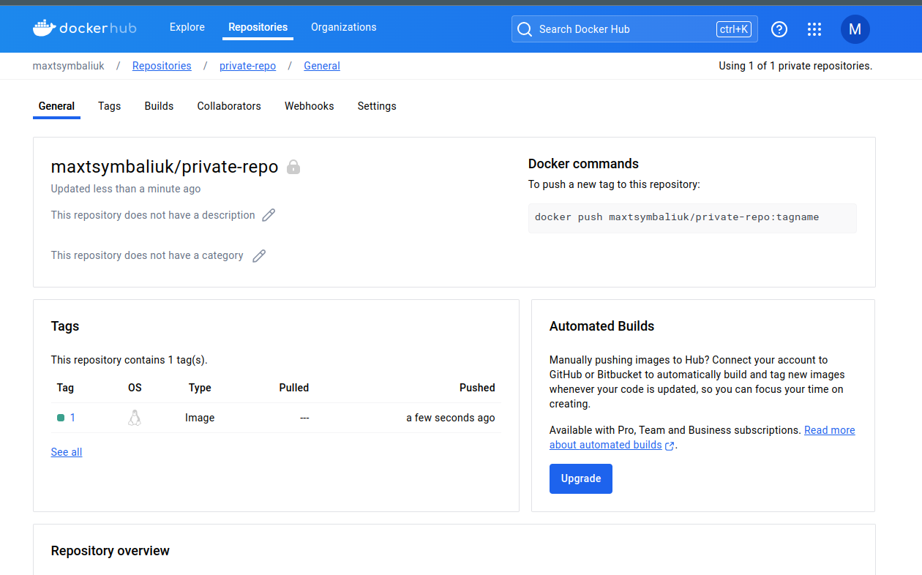

* Create a secret for accessing private registry with needed creds



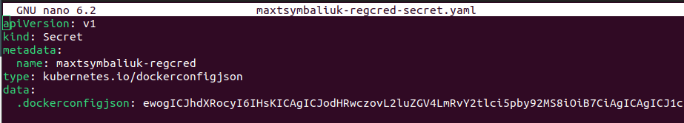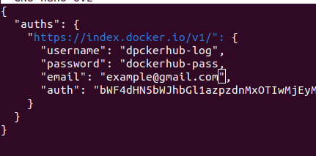

* Create a configmap with nginx config file listening on port 8080 instead of 80

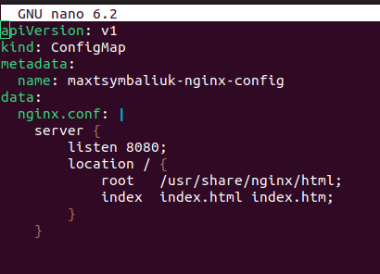

* Create a deployment with this private nginx image, registry secret attached and attached config from the configmap

